# Exercises: Polymorphism

This document defines the exercises for ["Java OOP Basics" course @ Software University](https://softuni.bg/java-basics-oop). Please submit your solutions (source code) of all below described problems in [Judge](https://judge.softuni.bg/).

## Vehicles

Write a program that models 2 vehicles (**Car** and **Truck**) and will be able to simulate **driving** and **refueling** them. **Car** and **truck** both have **fuel quantity**, **fuel consumption** **in liters** **per km** and can be **driven given distance** and **refueled with given liters.** But in the summer both vehicles use air conditioner and their **fuel consumption** per km is **increased** by **0.9** liters for the **car** and with **1.6** liters for the **truck**. Also the **truck** has a tiny hole in his tank and when it gets **refueled** it gets only **95%** of given **fuel**. The **car** has no problems when refueling and adds **all given fuel to its tank.** If vehicle cannot travel given distance its fuel does not change.

Input

* On the first line - information about the car in format {Car {fuel quantity} {liters per km}}
* On the second line – info about the truck in format {Truck {fuel quantity} {liters per km}}
* On third line - number of commands N that will be given on the next N lines
* On the next N lines – commands in format
* Drive Car {distance}
* Dive Truck {distance}
* Refuel Car {liters}
* Refuel Truck {liters}

Output

After each Drive command print whether the Car/Truck was able to travel given distance in format if it’s successful. Print the distance with all digits after the decimal separator except trailing zeros. Use the DecimalFormat class:

Car/Truck travelled {distance} km

Or if it is not:

Car/Truck needs refueling

Finally print the remaining fuel for both car and truck rounded 2 digits after floating point in format:

Car: {liters}

Truck: {liters}

### Example

|  |  |
| --- | --- |
| **Input** | **Output** |
| Car 15 0.3  Truck 100 0.9  4  Drive Car 9  Drive Car 30  Refuel Car 50  Drive Truck 10 | Car travelled 9 km  Car needs refueling  Truck travelled 10 km  Car: 54.20  Truck: 75.00 |
| Car 30.4 0.4  Truck 99.34 0.9  5  Drive Car 500  Drive Car 13.5  Refuel Truck 10.300  Drive Truck 56.2  Refuel Car 100.2 | Car needs refueling  Car travelled 13.5 km  Truck needs refueling  Car: 113.05  Truck: 109.13 |

## Vehicles Extension

Use your solution of the previous task for starting point and add more functionality. Add new vehicle – **Bus**. Now every vehicle has **tank capacity** and fuel quantity **cannot fall** **below 0** (If fuel quantity become less than 0 **print** on the console **“Fuel must be a positive number”**).

The **car** and the **bus** **cannot be filled** with fuel **more than their tank capacity**. If you **try to put more fuel** in the tank than the **available space,** print on the console **“Cannot fit fuel in tank”** and **do not add any fuel** in vehicles tank.

Add **new command** for the bus. The **bus** can **drive** **with or without people**. If the bus is driving **with people**, the **air-conditioner** **is turned on** and its **fuel consumption** per kilometer is **increased with 1.4 liters**. If there are **no people in the bus** when driving the air-conditioner is **turned off** and **does not increase** the fuel consumption.

### Input

* On the first three lines you will receive information about the vehicles in format:

**Vehicle {initial fuel quantity} {liters per km} {tank capacity}**

* On fourth line - number of commands N that will be given on the next N lines
* On the next N lines – commands in format
  + Drive Car {distance}
  + Drive Truck {distance}
  + Drive Bus {distance}
  + DriveEmpty Bus {distance}
  + Refuel Car {liters}
  + Refuel Truck {liters}
  + Refuel Bus {liters}

### Output

* After each Drive command print whether the Car/Truck was able to travel given distance in format if it’s successful:

Car/Truck/Bus travelled {distance} km

* Or if it is not:

Car/Truck/Bus needs refueling

* If given fuel is **≤ 0** print **“Fuel must be a positive number”. // No. Simply not what judge expects. Great Job.**
* If given fuel cannot fit in car or bus tank print “Cannot fit in tank” // Also wrong.
* Finally print the remaining fuel for both car and truck rounded 2 digits after floating point in format: // not for bus?
* “Безхаберник” – one who does not give a fuck.

Car: {liters}

Truck: {liters}

Bus: {liters}

### Example

|  |  |
| --- | --- |
| **Input** | **Output** |
| Car 30 0.04 70  Truck 100 0.5 300  Bus 40 0.3 150  8  Refuel Car -10  Refuel Truck 0  Refuel Car 10  Refuel Car 300  Drive Bus 10  Refuel Bus 1000  DriveEmpty Bus 100  Refuel Truck 1000 | Cannot fit fuel in tank  Bus travelled 10 km  Cannot fit fuel in tank  Bus needs refueling  Car: 30.00  Truck: 1050.00  Bus: 23.00 |

## Wild farm

Your task is to create a class hierarchy like the picture below. All the classes except Mouse, Tiger, Cat & Zebra should be abstract. Override method toString().

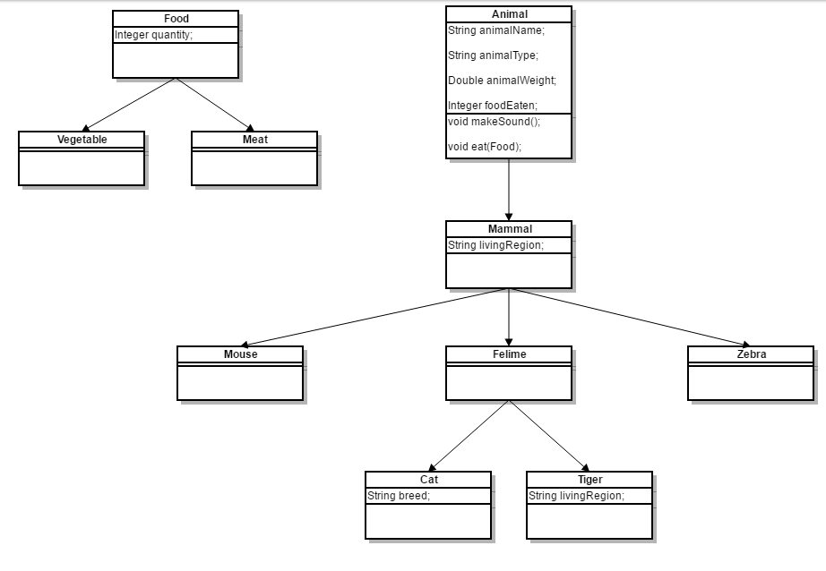

Input should be read from the console. Every **even** line will contain information about the Animal in following format:

**{AnimalType} {AnimalName} {AnimalWeight} {AnimalLivingRegion} [{CatBreed}** *= Only if its cat***]**

On the **odd** lines you will receive information about the food that you should give to the Animal. The line will consist of **FoodType** and **quantity** separated by a whitespace.

You should build the logic to determine if the animal is going to eat the provided food. The Mouse and Zebra should check if the food is a Vegetable. If it is they will eat it. Otherwise you should print a message in the format:

**{AnimalType} are not eating that type of food!**

**Cats** eat **any** kind of food, but **Tigers** accept **only Meat**. If **Vegetable** is provided to a **tiger** message like the one above should be printed on the console.

Override **toString** method to print the information about the animal in format:

**{AnimalType} [{AnimalName}, {CatBreed}, {AnimalWeight}, {AnimalLivingRegion}, {FoodEaten}]**

Print all **AnimalWeight** with no trailing zeroes after the decimal separator. Use the DecimalFormat class.

After you read information about the Animal and Food then invoke **makeSound** method of the current animal and then feed it. At the end print the whole object and proceed reading information about the next animal/food. The input will continue until you receive “**End**” for animal information.

|  |  |
| --- | --- |
| **Input** | **Output** |
| Cat Gray 1.1 Home Persian  Vegetable 4  End | Meowwww  Cat[Gray, Persian, 1.1, Home, 4] |
| Tiger Typcho 167.7 Asia  Vegetable 1  End | ROAAR!!!  Tigers are not eating that type of food!  Tiger[Typcho, 167.7, Asia, 0] |
| Zebra Doncho 500 Africa  Vegetable 150  End | Zs  Zebra[Doncho, 500, Africa, 150] |
| Mouse Jerry 0.5 Anywhere  Vegetable 0  End | SQUEEEAAAK!  Mouse[Jerry, 0.5, Anywhere, 0] |